Data

Train 1

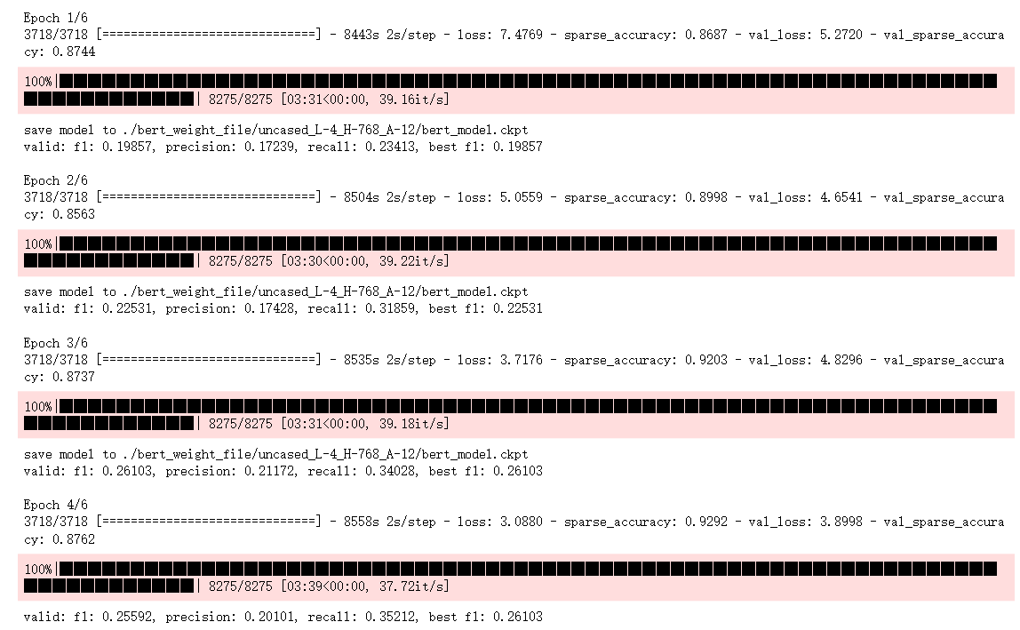

Data

Train 2

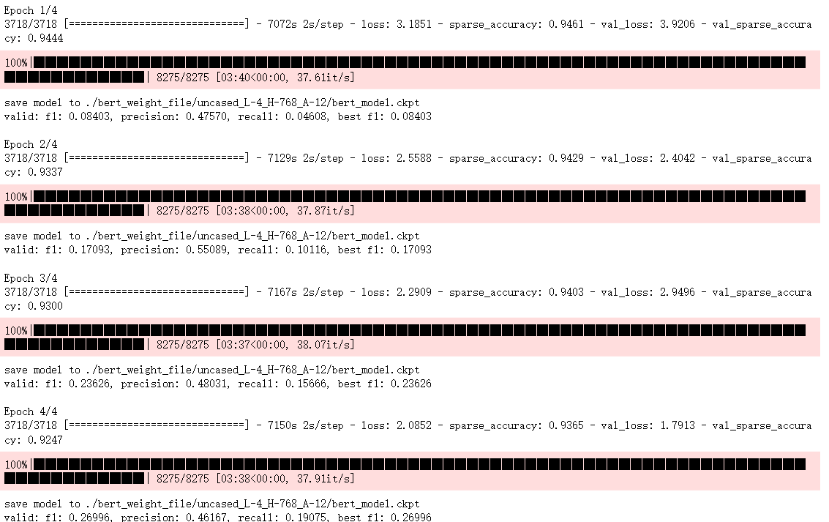

Data_ner

Train 1

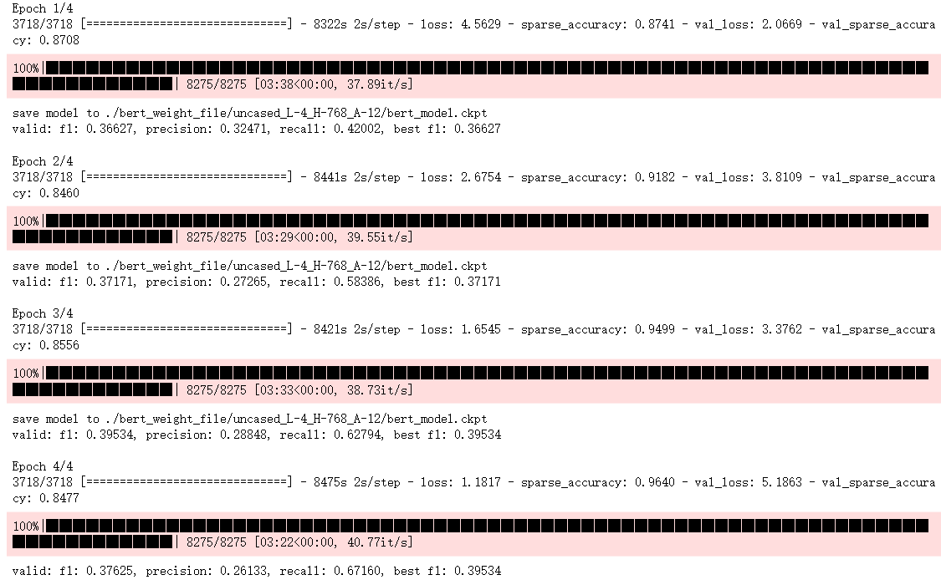

Data_ner

Train 2

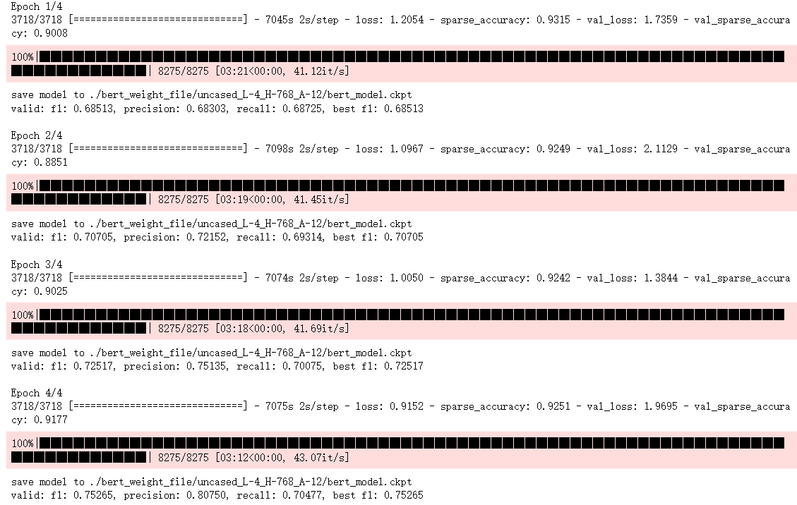

Data_ner

Train 1

Epoch = 8

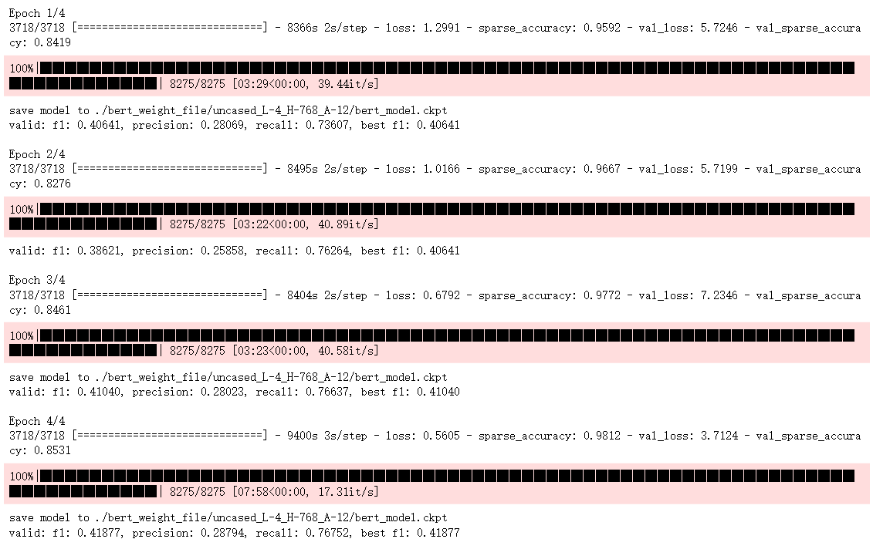

Data_ner

Train2

Epoch = 1

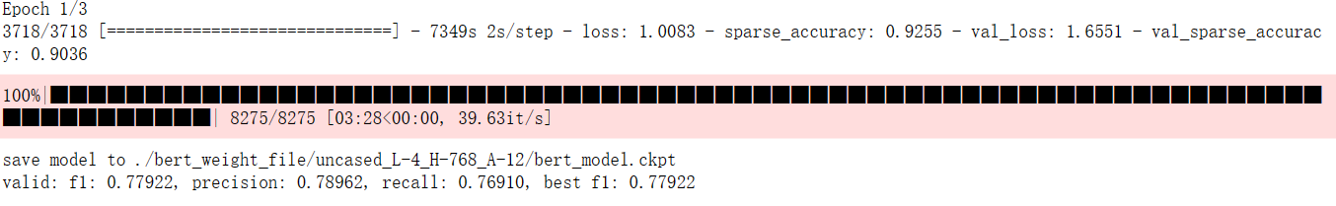

Data_ner

Train 1

Epoch = 4

Chinese-BERT-wwm

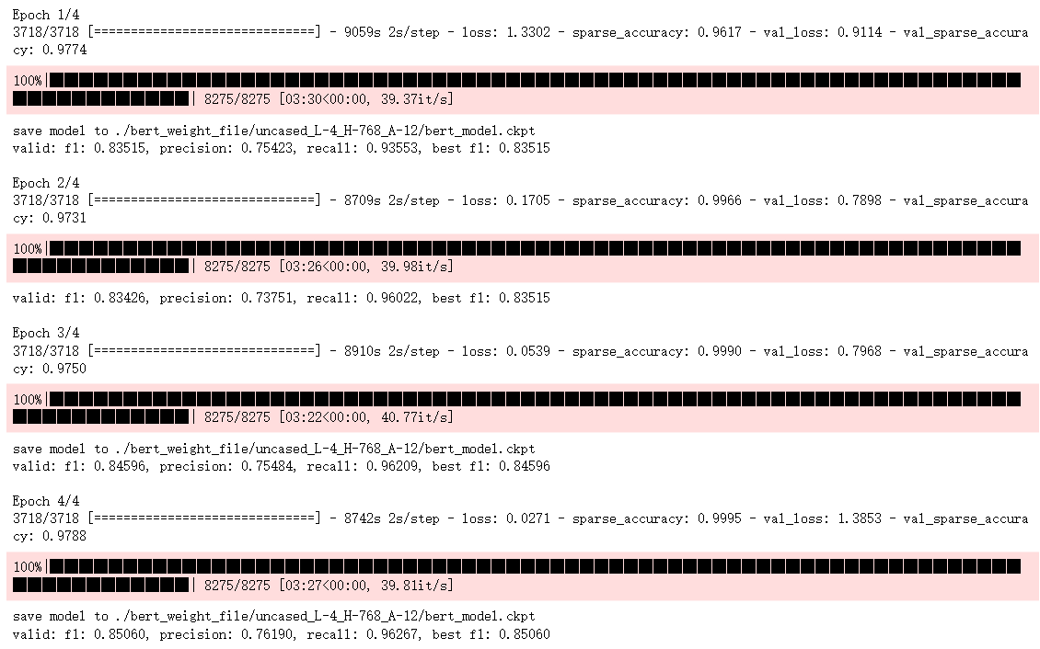

Data_ner

Train 2

Epoch = 4

Chinese-BERT-wwm

